THE DELAWARE GUIDEBOOK PROJECT
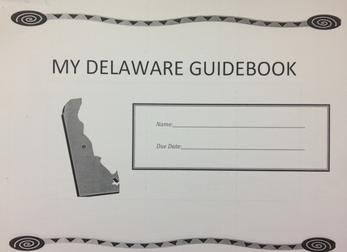

The Delaware Guidebook Project was assigned to room 303 on February 26, 2014. Class time was used to explain each section of the project. Each student is required to complete this project by March 28, 2014. If you feel as if you might have a problem with this date, please contact me as soon as possible. You may also turn in the project early.
Students should maintain their project in a neat and orderly fashion. I will not be giving out multiple copies of the assignment due to the sheer amount of paper it requires to make each individual project. If you need to reprint and individual page or the entire document, you can go to the class website http://jbonavita.weebly.com, & look in the “school zone”.
Each student is given multiple resources to use to research their project. They are allowed to borrow 3 books from me about Delaware, use the website to find information, or ask an adult for some information. This project is student-friendly in that each child can successfully complete this assignment on their own.

The students are encouraged to be as creative as possible!

*** ALSO: The students are encouraged to create their guidebook using Google Presentation (We have used this program once before), or in a Google Doc. They will need to re-create the pages within their Google Drive, & save them as a new presentation or document. This would require more work & effort, but if a student commits to this I will give him or her more leeway with the due date. The student just needs to let me know that is what they are doing.
Time management is key. Do a page a day and the assignment will be done in a snap! Don't wait until the night before and lose sleep and turn in a project that isn't stellar. Be neat. Follow the RUBRIC. Ask questions.
Good luck and remember due date is... March 28, 2014!!!!!

Thank you for taking the time to read this!

Mr. Bonavita

