C:\Users\jbonavita\AppData\Local\Microsoft\Windows\Temporary Internet Files\Content.IE5\LBV2LUZG\MC900158007[1].wmf

MY DELAWARE GUIDEBOOK

C:\Users\jbonavita\AppData\Local\Microsoft\Windows\Temporary Internet Files\Content.IE5\DWM2T2FI\MC900013534[1].wmf

*Name:_________________________________________________________*

*Due Date:_____________________________________________________*

C:\Users\jbonavita\AppData\Local\Microsoft\Windows\Temporary Internet Files\Content.IE5\LBV2LUZG\MC900158007[1].wmf

C:\Users\jbonavita\AppData\Local\Microsoft\Windows\Temporary Internet Files\Content.IE5\LBV2LUZG\MC900158007[1].wmf

Delaware’s State Flag

|  |
| --- |
|  |

C:\Users\jbonavita\AppData\Local\Microsoft\Windows\Temporary Internet Files\Content.IE5\LBV2LUZG\MC900158007[1].wmf

C:\Users\jbonavita\AppData\Local\Microsoft\Windows\Temporary Internet Files\Content.IE5\LBV2LUZG\MC900158007[1].wmf

C:\Users\jbonavita\AppData\Local\Microsoft\Windows\Temporary Internet Files\Content.IE5\DWM2T2FI\MC900027379[1].wmf

Our state is named:_________________________________________

It’s postal abbreviation is:____________________________________

Our state is bordered by 3 other states. List them, & label the map.

1.______________________________________

2.______________________________________

3.______________________________________

C:\Users\jbonavita\AppData\Local\Microsoft\Windows\Temporary Internet Files\Content.IE5\LBV2LUZG\MC900158007[1].wmf

C:\Users\jbonavita\AppData\Local\Microsoft\Windows\Temporary Internet Files\Content.IE5\LBV2LUZG\MC900158007[1].wmf

Delaware became a state on

____________________________________________________________

Month Date Year

Delaware’s State Capital is:

______________________________________________________________

C:\Users\jbonavita\AppData\Local\Microsoft\Windows\Temporary Internet Files\Content.IE5\LBV2LUZG\MC900158007[1].wmf

C:\Users\jbonavita\AppData\Local\Microsoft\Windows\Temporary Internet Files\Content.IE5\LBV2LUZG\MC900158007[1].wmf

Delaware’s State Seal

C:\Users\jbonavita\AppData\Local\Microsoft\Windows\Temporary Internet Files\Content.IE5\LBV2LUZG\MC900158007[1].wmf

C:\Users\jbonavita\AppData\Local\Microsoft\Windows\Temporary Internet Files\Content.IE5\LBV2LUZG\MC900158007[1].wmf

The State Fish is:____________________

Delaware’s nicknames are: 1._______________ 2._________________

3._____________________

C:\Users\jbonavita\AppData\Local\Microsoft\Windows\Temporary Internet Files\Content.IE5\DWM2T2FI\MC900127781[1].wmf

C:\Users\jbonavita\AppData\Local\Microsoft\Windows\Temporary Internet Files\Content.IE5\LBV2LUZG\MC900158007[1].wmf

C:\Users\jbonavita\AppData\Local\Microsoft\Windows\Temporary Internet Files\Content.IE5\LBV2LUZG\MC900158007[1].wmf

The State Tree is:_____________________

The State Insect is:_______________________

C:\Users\jbonavita\AppData\Local\Microsoft\Windows\Temporary Internet Files\Content.IE5\LBV2LUZG\MC900158007[1].wmf

C:\Users\jbonavita\AppData\Local\Microsoft\Windows\Temporary Internet Files\Content.IE5\LBV2LUZG\MC900158007[1].wmf

The State Flower is:_____________________

The State Bird is:_____________________

C:\Users\jbonavita\AppData\Local\Microsoft\Windows\Temporary Internet Files\Content.IE5\LBV2LUZG\MC900158007[1].wmf

C:\Users\jbonavita\AppData\Local\Microsoft\Windows\Temporary Internet Files\Content.IE5\LBV2LUZG\MC900158007[1].wmf

GOVERNMENT

The center of Delaware’s government is located in

____________________________, our capital city.

The Governor is:

____________________

C:\Users\jbonavita\AppData\Local\Microsoft\Windows\Temporary Internet Files\Content.IE5\LBV2LUZG\MC900158007[1].wmf

C:\Users\jbonavita\AppData\Local\Microsoft\Windows\Temporary Internet Files\Content.IE5\LBV2LUZG\MC900158007[1].wmf

The two U.S. Senators that represent us in Washington D.C. are:

____________________________________________ ________________________________________

Name Name

C:\Users\jbonavita\AppData\Local\Microsoft\Windows\Temporary Internet Files\Content.IE5\LBV2LUZG\MC900158007[1].wmf

C:\Users\jbonavita\AppData\Local\Microsoft\Windows\Temporary Internet Files\Content.IE5\LBV2LUZG\MC900158007[1].wmf

The one member of the House of Representatives from Delaware is:

____________________________________________

Name

C:\Users\jbonavita\AppData\Local\Microsoft\Windows\Temporary Internet Files\Content.IE5\LBV2LUZG\MC900158007[1].wmf

C:\Users\jbonavita\AppData\Local\Microsoft\Windows\Temporary Internet Files\Content.IE5\LBV2LUZG\MC900158007[1].wmf

Name & show FOUR of Delaware’s historical figures

C:\Users\jbonavita\AppData\Local\Microsoft\Windows\Temporary Internet Files\Content.IE5\LBV2LUZG\MC900158007[1].wmf

C:\Users\jbonavita\AppData\Local\Microsoft\Windows\Temporary Internet Files\Content.IE5\LBV2LUZG\MC900158007[1].wmf

The TWO American Indian tribes that lived in Delaware were:

1. **_______________________________________________________________**

C:\Users\jbonavita\AppData\Local\Microsoft\Windows\Temporary Internet Files\Content.IE5\DWM2T2FI\MC900022330[1].wmf 2. __________________________________________________________ C:\Users\jbonavita\AppData\Local\Microsoft\Windows\Temporary Internet Files\Content.IE5\J7ME4YHQ\MC900355919[1].wmf

C:\Users\jbonavita\AppData\Local\Microsoft\Windows\Temporary Internet Files\Content.IE5\LBV2LUZG\MC900158007[1].wmf

C:\Users\jbonavita\AppData\Local\Microsoft\Windows\Temporary Internet Files\Content.IE5\LBV2LUZG\MC900158007[1].wmf

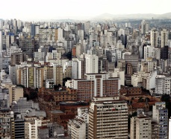 **Delaware Cities** 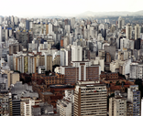

List the THREE counties in Delaware, then list TWO cities from each county

City:______________________________________

County:_________________

City:______________________________________

City:______________________________________

County:_________________

City:______________________________________

City:______________________________________

County:_________________

City:______________________________________

C:\Users\jbonavita\AppData\Local\Microsoft\Windows\Temporary Internet Files\Content.IE5\LBV2LUZG\MC900158007[1].wmf

C:\Users\jbonavita\AppData\Local\Microsoft\Windows\Temporary Internet Files\Content.IE5\LBV2LUZG\MC900158007[1].wmf

MY CITY

Tell where you live, & draw a picture to illustrate your city.

C:\Users\jbonavita\AppData\Local\Microsoft\Windows\Temporary Internet Files\Content.IE5\LBV2LUZG\MC900158007[1].wmf

C:\Users\jbonavita\AppData\Local\Microsoft\Windows\Temporary Internet Files\Content.IE5\LBV2LUZG\MC900158007[1].wmf

Name & show FOUR of Delaware’s famous landmarks

C:\Users\jbonavita\AppData\Local\Microsoft\Windows\Temporary Internet Files\Content.IE5\LBV2LUZG\MC900158007[1].wmf

C:\Users\jbonavita\AppData\Local\Microsoft\Windows\Temporary Internet Files\Content.IE5\LBV2LUZG\MC900158007[1].wmf

Name THREE of Delaware’s state parks

1. ____________________________________________ 2. ___________________________________________

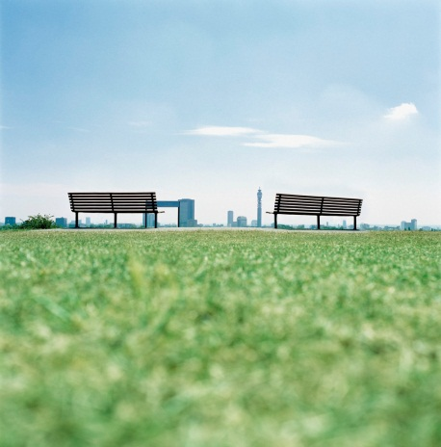

3._______________________________________________

C:\Users\jbonavita\AppData\Local\Microsoft\Windows\Temporary Internet Files\Content.IE5\LBV2LUZG\MC900158007[1].wmf

C:\Users\jbonavita\AppData\Local\Microsoft\Windows\Temporary Internet Files\Content.IE5\LBV2LUZG\MC900158007[1].wmf

Name THREE major waterways in our state

1.___________________________________________



2.___________________________________________

3.___________________________________________

C:\Users\jbonavita\AppData\Local\Microsoft\Windows\Temporary Internet Files\Content.IE5\LBV2LUZG\MC900158007[1].wmf

C:\Users\jbonavita\AppData\Local\Microsoft\Windows\Temporary Internet Files\Content.IE5\LBV2LUZG\MC900158007[1].wmf

Name & illustrate 4 different sports played in Delaware

C:\Program Files\Microsoft Office\MEDIA\CAGCAT10\j0183168.wmf 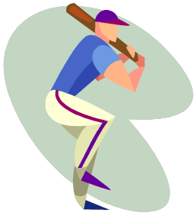

C:\Program Files\Microsoft Office\MEDIA\CAGCAT10\j0299763.wmf C:\Program Files\Microsoft Office\MEDIA\CAGCAT10\j0301480.wmf

C:\Users\jbonavita\AppData\Local\Microsoft\Windows\Temporary Internet Files\Content.IE5\LBV2LUZG\MC900158007[1].wmf

C:\Users\jbonavita\AppData\Local\Microsoft\Windows\Temporary Internet Files\Content.IE5\LBV2LUZG\MC900158007[1].wmf

Name FOUR colleges or universities in Delaware

C:\Users\jbonavita\AppData\Local\Microsoft\Windows\Temporary Internet Files\Content.IE5\B5J7E0B7\MC900056794[1].wmf 1.________________________________________

2._______________________________________

3._______________________________________________



4._______________________________________________

C:\Users\jbonavita\AppData\Local\Microsoft\Windows\Temporary Internet Files\Content.IE5\LBV2LUZG\MC900158007[1].wmf